1. https://news.laodong.vn/van-hoa-giai-tri/sau-concert-my-dinh-taeyang-bigbang-lien-tuc-nhac-den-pho-va-show-tuyet-voi-nhat-1791777.ldo

After the My Dinh concert, Taeyang (BigBang) continuously mentioned "pho" and "the best show"
VÂN CHI - 11:57, Fri Oct 30, 2026 (GMT+7)
Taeyang (BigBang) continuously expresses his feelings for Vietnam, making Vietnamese fans happy.
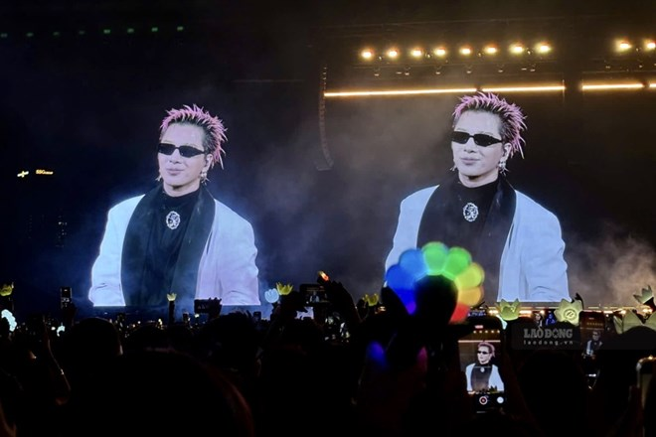Taeyang at BigBang's concert in My Dinh. Photo: Huyen Chi
BIGBANG 2026–2027 World Tour in Hanoi concert took place in two nights, October 24 and 25, 2026 at My Dinh National Stadium, Hanoi.
On the occasion of the group's 20th anniversary, 3 members G-Dragon, Taeyang and Daesung brought memorable performances, attracting a large number of fans and contributing to creating attraction for the Vietnamese entertainment and tourism market.
On the evening of October 29, Taeyang (BigBang) posted a video and a series of behind-the-scenes photos of the concert in Vietnam, but what attracted the most attention was the accompanying caption. The voice of "Eyes, nose, lips" played words by replacing the word "Pho" with "for" in the paragraph.
Taeyang has long loved pho after performing in Vietnam, he created interesting paragraphs with the word "pho" such as: "Pho me" (For me - for me), "Pho all of us" (For all of us - for all of us), "Phogive me" (Forgive me - forgive me), "Pho'ever" (Forever - forever)...
Not only that, in the end of the clip, Taeyang affirmed: "From my point of view, this is the best show! ".
Taeyang's clip made Vietnamese fans' hearts flutter, and they simultaneously sent comments expressing their feelings for Taeyang as well as for BigBang.
During the performance at My Dinh, Taeyang made many fans excited when he said: "I love you guys" in Vietnamese. He also instructed the audience to chant "Vietnam champion!".
3 members Daesung, Taeyang and G-Dragon in the BigBang concert in My Dinh. Photo: Thuy Trang.
Taeyang (real name Dong Young-bae, born in 1988) is a famous Korean singer and dancer and one of the three members of the K-pop group BigBang.
Possessing a distinctive R&B voice, impressive dance ability and attractive performance style, Taeyang not only made his mark in group activities but also built a successful solo career with many popular songs such as "Eyes, nose, lips", "Ringa linga", "I need a girl" and "Vibe" in collaboration with Jimin (BTS).
As of October 2026, Taeyang has been to Vietnam twice. The first time was in June 2023, he participated in the 2023 SEEN Festival held in Hoi An, Quang Nam. During this occasion, the male singer received a lot of attention from Vietnamese fans.
After more than three years, Taeyang returned to Vietnam in October 2026 with G-Dragon and Daesung within the framework of BIGBANG 2026–2027 WORLD TOUR, with two performances on October 24 and 25 at My Dinh National Stadium, Hanoi.
This return not only marks a special milestone in BIGBANG's 20th anniversary journey but also an opportunity for Taeyang to meet and connect with Vietnamese fans once again.
2. https://edition.cnn.com/2026/11/01/entertainment/megan-thee-stallion-halloween-costume

The story behind Megan Thee Stallion’s elaborately spooky Halloween costume
By Lisa Respers France
NOV 1, 2026

Megan Thee Stallion at the second fitting for her costume created by Cirque du Soleil. Hot Girl Productions
Megan Thee Stallion
People in entertainment
See all topics
Megan Thee Stallion takes her Hottieween very seriously.
The rapper and actress this year wore an elaborate orange-black-and-white look designed by Cirque du Soleil, in keeping with the “Thee Circus is Coming” theme for her annual Halloween celebration, held this year in Las Vegas.
“It’s a riff off of many Cirque de Soleil shows and the elaborate costumes, kind of taking inspirations from some of the iconic Cirque de Soleil pieces and creating something whimsical that belongs to Megan Thee Stallion’s world,” costume designer Miodrag “Mio” Guberinic said in an interview.
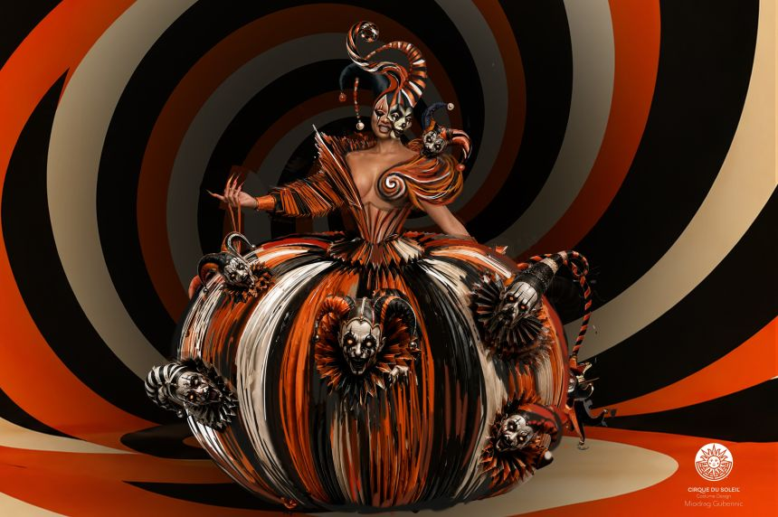
Concept design sketch for the Towering Arrival First Look of Megan Thee Stallion. Miodrag Guberinic/Cirque du Soleil
The elaborate get up took 23 artists more than 700 hours to craft, using more than 50 yards of fabric. It included a voluminous skirt embellished with jester faces that look like scary pumpkins, as Guberinic said the star has always included pumpkin imagery as part of her past postings on social media celebrating Halloween, as well as a headpiece and layers that allowed Megan Thee Stallion to shed pieces throughout the night.
The design took so much time in part because of the intricacies including an accordion sleeve built from 120 individually patterned pieces. The giant origami pumpkin skirt comprises12 panels, each nearly six feet tall, using more than 400 square feet of custom-printed, hand-painted material. The skirt was decorated with 13 3D-printed jester embellishments ;more than 50 magnets allowed the skirt to separate into four sections.
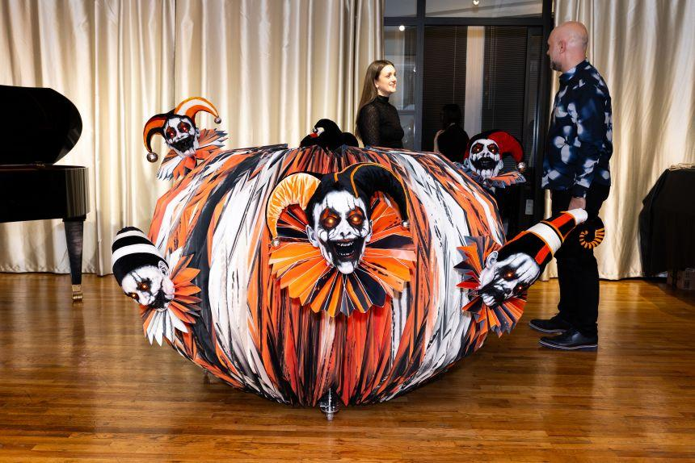
Costume designer Miodrag “Mio” Guberinic and an artisan with Megan's voluminous skirt embellished with jester faces. Hot Girl Productions
“Working with Cirque du Soleil on this year’s Hottieween costume was such an amazing experience,” Megan said. “The amount of preparation, creativity and attention to detail that went into bringing everything to life was incredible. It was the perfect way to set the tone for another unforgettable Hottieween celebration.”
Gabriel Dubé-Dupuis, Cirque du Soleil’s creative director, said Megan was thrilled by the initial mock up.
“When I welcomed her in New York City at Mio’s studio, she was like a kid she was so excited,” Dubé-Dupuis said. “When she walked in the room, she just screamed. She started taking pictures and video of herself with it before we even got started.”
The woman known for her killer body and revealing outfits did have a request, however.
Known for showing off her enviable figure, the star had one request.
“She just wanted to be revealed more,” Guberinic said. “She wants to be sexier, so we kind of opened up and showed more of her skin.”
Megan Thee Stallion also wanted something that transformed throughout the night from an attention-grabbing entrance at the club to something she could rock while partying with her guests.
“One of the first things she said when she saw the mock-up and tested it in New York, she said, ‘I see myself in this. I see myself in this through the night,’” Dubé-Dupuis said.
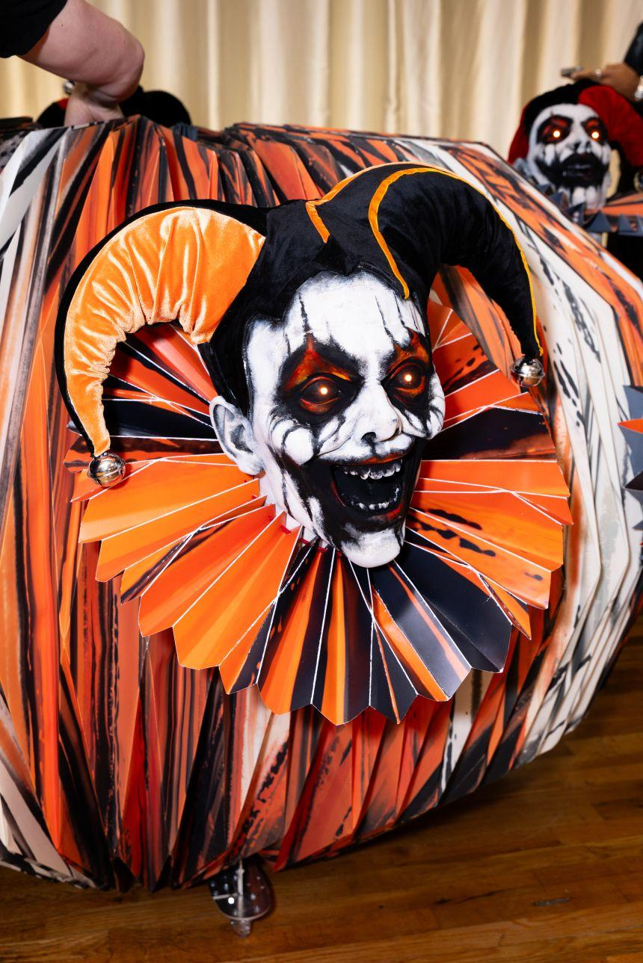
Geronimo, the main jester head, positioned at the center of the pumpkin skirt. Hot Girl Productions
The Grammy-winning artist is known for doing it big and her career this past year has reinforced that.
In March, she made her Broadway debut in the role of Harold Zidler in “Moulin Rouge! The Musical” which led to her both performing and presenting at this year’s Tony Awards.
In late October, she headlined the Victoria’s Secret Fashion Show and last week she released an EP titled “Tina Tuesday Freestyles.”
Megan launched Hottieween in 2019 and has so far held the event in Las Vegas, Los Angeles, Atlanta, Chicago and her hometown of Houston.
Her past costumes have included a talking flower from Tim Burton’s “Alice in Wonderland” film, “Hellraiser’s” Pinhead, the anime character Mirko from “My Hero Academia” and Greta from “Gremlins 2: The New Batch.”
“I’ve always liked scary movies, I’ve always liked horror, thrillers, all that good stuff,” she told Jennifer Hudson last year. “If I could figure out how to turn a Freddy Krueger into a Freddy Hoochie, I was gonna do that. You know, like horror, but make it hot girl.”
A portion of the proceeds from this year’s Hottieween goes to Megan Thee Stallion’s Pete & Thomas Foundation.
3. https://www.health.harvard.edu/diet-and-nutrition/oat-vs-dairy-milk-nutrition-benefits-and-downsides?_gl=1*ippkt*_up*MQ..*_ga*MTM5MTg1MjEyOC4xNzkzNjkyMTY2*_ga_0BL4ZQBM0W*czE3OTM2OTIxNjYkbzEkZzAkdDE3OTM2OTIxNjYkajYwJGwwJGgw*_ga_W2SR8DW607*czE3OTM2OTIxNjYkbzEkZzAkdDE3OTM2OTIxNjYkajYwJGwwJGgw*_ga_2PZD5XNYSL*czE3OTM2OTIxNjYkbzEkZzAkdDE3OTM2OTIxNjYkajYwJGwwJGgw

Oat vs. dairy milk: Nutrition, benefits, and downsides

If you're allergic to cow's milk or follow a vegan diet, oat milk can be a good alternative.
October 22, 2026
By Julie Corliss, Executive Editor, Harvard Heart Letter
- Reviewed by Lauren Abeles, MS, RD, LDN, Contributor

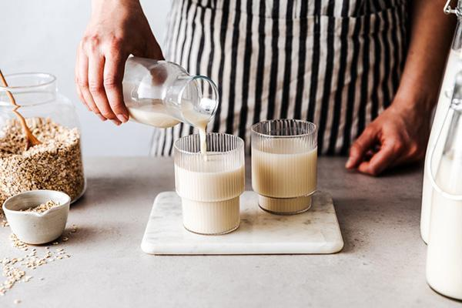
With its mild flavor and creamy texture, oat milk has become one of the most popular plant-based milks in recent years. But how does it stack up against regular cow’s milk? Here’s what to consider before buying a carton of oat milk or requesting it for your routine coffee order.

Is oat milk healthier than cow’s milk?
“If you have a true milk allergy — an abnormal, potentially serious immune system reaction to the proteins found in cow’s milk — oat milk is a healthier alternative to regular milk,” says Lauren Abeles, a registered dietitian at Harvard-affiliated Brigham and Women’s Faulkner Hospital. Oat milk is also free from other common allergens, such as soy and nuts, which are other common foods used to make plant-based milks.
For people who are vegan (that is, they strictly avoid all animal-based products), oat milk is one good option. But it’s not necessarily healthier than other plant-based milks, says Abeles. Soy milk, for example, contains 7 grams of protein per cup — nearly as much protein as cow’s milk and more than twice as much as oat milk.
You might also be interested in...
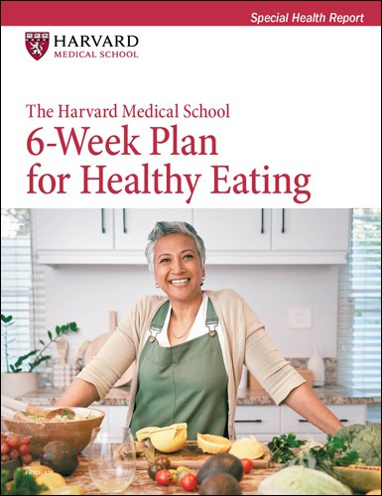

Harvard Health Publishing’s 6-Week Plan for Healthy Eating
This week-by-week plan, The Harvard Medical School 6-Week Plan for Healthy Eating, will help you transform your eating habits into a program of nutritious and delicious food choices that can last a lifetime. Applying the latest results from nutrition science, Harvard experts take you by the hand and guide you to create an eating plan to improve heart health, longevity, energy, and vitality.
LEARN MORE
Some people have trouble digesting a natural sugar in cow’s milk called lactose. People with this problem (known as lactose intolerance) can experience diarrhea, bloating, or gas after consuming dairy products. Oat and other plant-based milks don’t contain lactose. However, people who are sensitive to lactose can also opt for lactose-free milk, which may be preferable for either taste or nutrition reasons, says Abeles.

How do oat milk and cow’s milk compare nutritionally?
In addition to having less protein than dairy milk, oat milk contains more carbohydrates (see “Nutrients in cow’s milk vs. oat milk”). While the total fat levels are similar, cow’s milk has more saturated fat. Oat milk contains a small amount of fiber, while cow’s milk has none. Most oat milks are fortified with calcium and vitamin D at levels similar to those found in cow’s milk. But there are no set standards and the amounts can vary between brands, so check the label.
Your personal health and dietary needs can affect which milk makes the most sense for you. “If you’re trying to lose weight, you’re better off eating more protein and fewer carbs, so cow’s milk may be a better choice,” says Abeles. That’s also true for people with diabetes or prediabetes, since the carbs in oat milk can contribute to blood sugar elevations, she adds. Compared to cow’s milk, the per serving difference in carbs from oat milk may not seem that large. But the total amount adds up if you put oat milk in your cereal and coffee and use it for cooking, Abeles points out.
Of course, if you have several servings of 2% cow’s milk daily, the saturated fat adds up, too. According to the American Heart Association, people who need to lower their LDL cholesterol should limit their total daily saturated intake to 6% of their total daily calories, which translates to about 13 grams or less.

How can you choose a healthy oat milk?
When shopping for oat milk, read the nutrition label: a brand with a short list of ingredients is usually the healthiest option.
Smart strategies for achieving and maintaining a healthy weight

Lose Weight and Keep It Off
Successful weight loss depends largely on becoming more aware of your behaviors and starting to change them. Instead of relying on willpower, this process demands skill power. This Special Health Report, Lose Weight and Keep It Off, offers a range of solutions that have worked for many people and can be tailored to your needs.
LEARN MORE!
Some brands contain only organically grown oats, water, and sea salt. Others include additives that some people may want to avoid. They include
- added sugars or flavorings (like vanilla or cocoa) to enhance the flavor
- oils (such as canola or sunflower oil) to improve the texture and mouthfeel
- emulsifiers and stabilizers, such as xanthan gum, dipotassium phosphate, and soy lecithin, which help prevent the ingredients from separating and extend the product’s shelf life.
If you have celiac disease or non-celiac gluten sensitivity, make sure to look for a brand that is certified gluten free. Gluten-free oat milk is made from oats that are specially harvested, processed, and tested to prevent contamination with wheat, barley, or rye.
“Drinking milk, whether it’s dairy or plant-based, is a great source of nutrients and hydration. So it’s best to choose one that you like and will drink often,” says Abeles.

Nutrients in cow’s milk* vs. oat milk**
Product  (1 cup) | Calories | Total fat  (grams) | Saturated fat (grams) | Total carbs  (grams) | Fiber  (grams) | Protein  (grams) | Calcium  (mg) | Vitamin D  (international units)
Cow’s milk (2% fat) | 120 | 5 | 3 | 12 | 0 | 8 | 300 | 100
Oat milk (unsweetened) | 120 | 5 | 0.5 | 16 | 2 | 3 | 300 | 140

4. A new start after 60: At 26, I saw my dream Porsche. At 68, I built one from scratch
- Link gốc: https://www.theguardian.com/lifeandstyle/2026/nov/02/a-new-start-after-60-at-26-i-saw-my-dream-porsche-at-68-i-built-one-from-scratch
A new start after 60

A new start after 60: At 26, I saw my dream Porsche. At 68, I built one from scratch
Bill Drysdale could never afford the sports car he fell in love with as a young man. So when he retired, he went to night school to learn welding, and began assembling it, bit by bit ...

vowed, “I will have one of those.” As the years went by, the price of Drysdale’s dream car rose above £1m. “I realised I was never going to be able to buy one.” But when he retired, still harbouring the dream, he thought: “Why don’t I make one?”

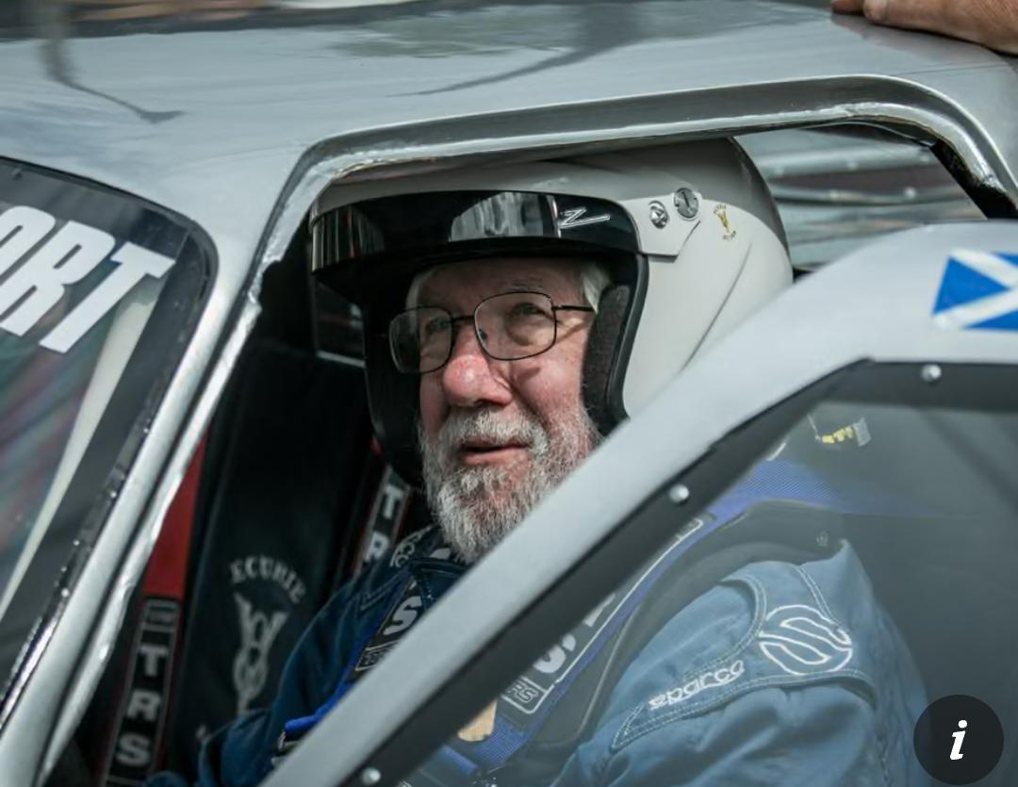

Drysdale grew up in Wigtown, Scotland, and cars were in his blood – his grandfather was chauffeur to the local creamery manager, and he first saw a race with his father, when he was 12 – around the time that his mother went into hospital with multiple sclerosis. Drysdale, an only child, grew close to his father. At 14, he taught him to drive. Together they’d huddle in the kitchen to listen to the Le Mans 24 Hour race on the radio.

Drysdale was only 21 when his dad died; his mother ended up staying in hospital for 23 years. “That made me very independent,” he says. Determined? “Pig-headed, some would say.”

After studying maths and physics at the University of Glasgow, he joined a brake manufacturer as a graduate apprentice engineer. “Oh, it was tremendous,” he says. “As young chaps in the company, there was always this interest in cars and racing and competition.” His favoured form was “sprinting – racing against the clock, competing against yourself”. It was while playing mechanic to a friend in the pit at Silverstone that he saw the Porsche 904 and was floored by “the sound, the look, the line”.

Drysdale married and became father to a son and a daughter, at which point he stopped motor racing. While his wife stayed at home in Warwickshire, England, he travelled widely for work – India, South Africa, Brazil, Japan, Argentina, Europe, Australia. By the time he retired at the age of 58, he was international president for a Canadian company, and moved back to Scotland. It was here that he had the idea to build his own version of the famous Porsche.

Drysdale went to night school for six months to learn how to weld. Through a friend of a friend of a friend, he got a blueprint of the original Porsche 904. He made the shape of the body in his garage, first from wood, then plaster of paris. From this he made fibreglass moulds; his wife, Lucia, helped him to make the resin. Next came the doors, a bonnet, front and rear wings, the interior and instrument panel.

“Once I had the body, I could concentrate on the engineering, fabricating the chassis, designing the suspension. That was all from scratch,” he says. He bought a secondhand engine and transmission – “then started to put all the parts together”.

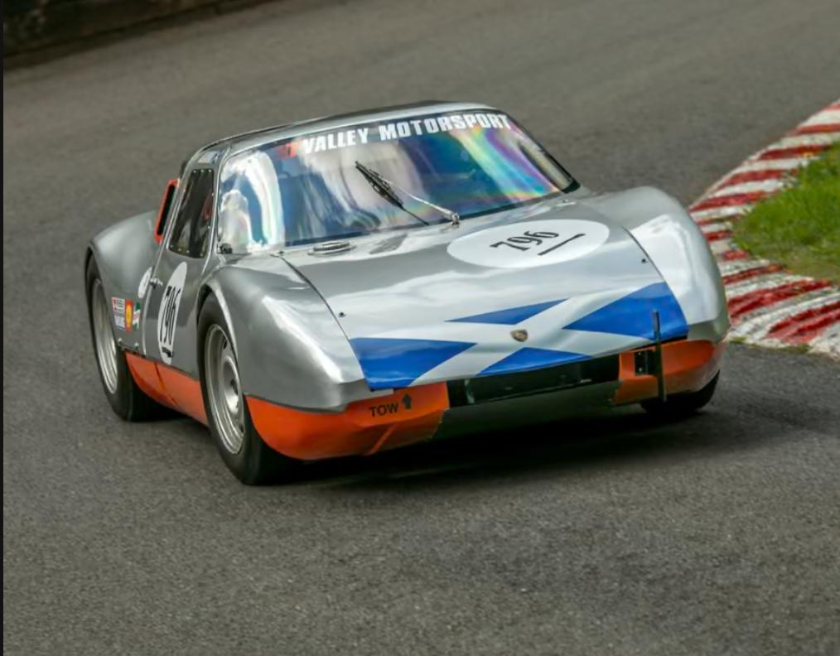
Drysdale driving his ‘Porsche 904FF’. Photograph: Joy Richings
The children “thought I was off my rocker”, he says. Sometimes, the project would defeat him. “For a couple of months I would not go into the garage at all. Then the enthusiasm would come back … I’ve always been interested in broadening myself.” After eight years, the car was finished; Drysdale was 68. He calls his car a Porsche 904FF. The double Fs stand for “effing fake”.

When it was done, he transported the car to test days at race tracks, where he did laps to set up the handling. In Scotland, England, France and Switzerland, he competed in speed hill climbs and sprints, right until February this year, when at 87 a stroke affected his sight and put paid to driving.

“I’m coming to terms with it but it is very difficult,” he says. Meanwhile, the car continues to compete, driven by friends, while Drysdale takes part as “entrant”. He is already planning the next season. “I intend to be in the paddock, in the pit, next year with my race car, with someone else driving it.”

“I think my dad would have said: ‘Yep, that’s my son,’” he says. “The car has given me a dream. I’m a great believer that you must have a dream. A dream to me is something you really would like to do but don’t know if you ever will. That’s my philosophy in life. Look forward. And do the things that you want to do.”

